Celebrate the
Feast of Our Lady of the Rosary
with Roses for Our Lady

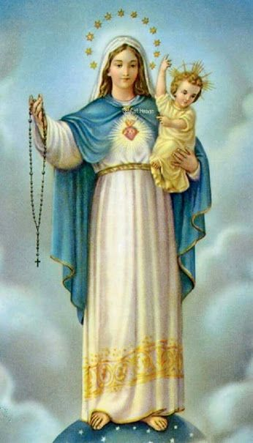 | Sunday, October 9, 2022  2:00 pm  Fr. Tim Kitzke presiding  St. John the Evangelist Church  8500 W. Coldspring Rd  ​Greenfield, WI 53228

An outdoor rosary procession will be included as part of our regular Holy Hour for Vocations.

www.rosesforourlady.org

