Celebrate the
Nativity of the Blessed Mother
with Roses for Our Lady
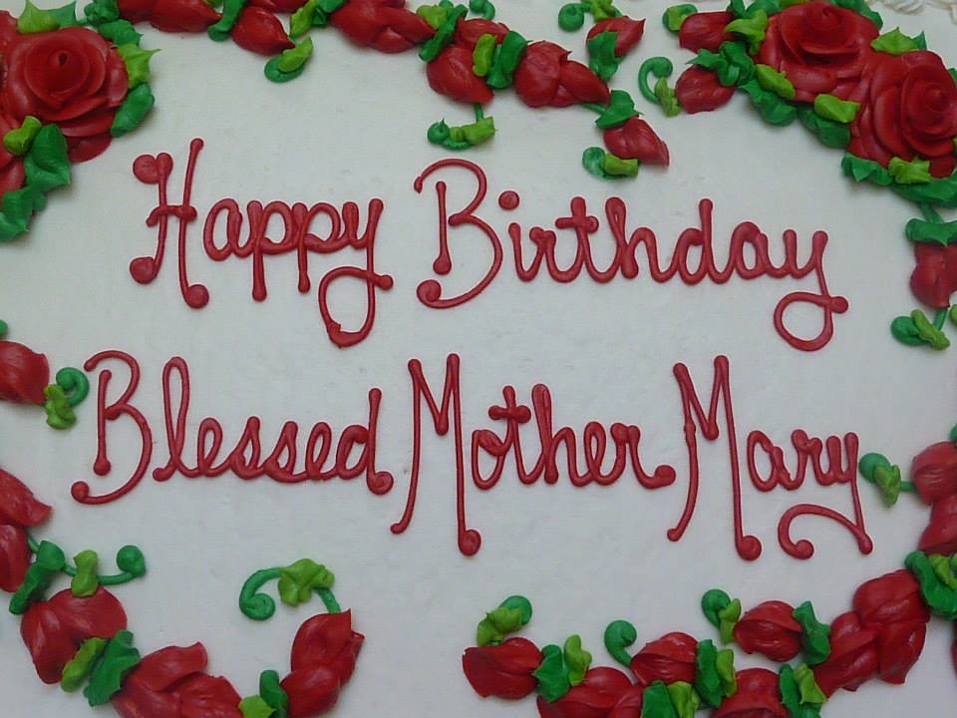 | 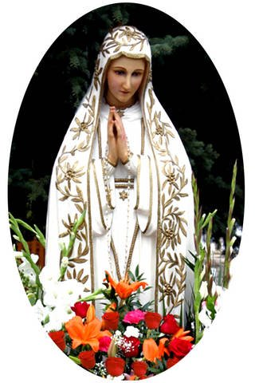
Sunday, September 11, 2022
2:00 pm
Fr. Tim Kitzke presiding
St. John the Evangelist Church
8500 W. Coldspring Rd
​Greenfield, WI 53228

An outdoor rosary procession will be included as part of our regular Holy Hour for Vocations.
A birthday party with cake and beverages will follow our Holy Hour.
Please bring a non-perishable food item for donation to the parish food pantry as a birthday gift for Our Lady.
www.rosesforourlady.org

