May Crowning Celebration

Sunday, May 12th, 2024 (Mother’s Day)
2:00 pm
Archdiocesan Marian Shrine
141 N. 68th St. Milwaukee, WI 53213
68th & Stevenson (just north of I-94)

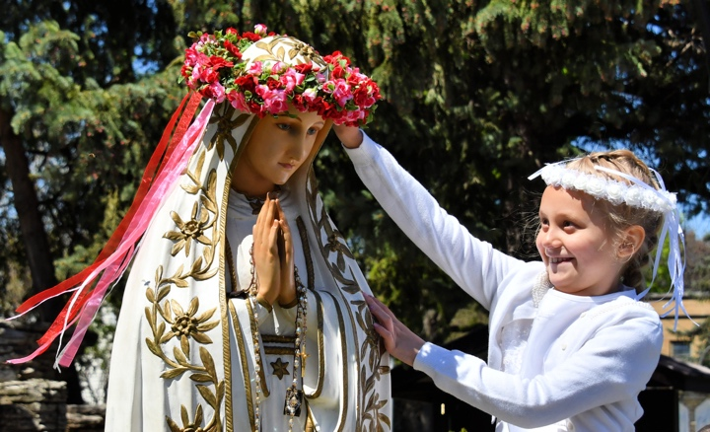 | Presider: Archbishop Jerome Listecki (Archdiocese of Milwaukee)  Assisted by: Fr. Joseph Heit and other clergy  The event will include:  - Crowning of Our Lady’s statue by First Communicants  - Exposition of the Blessed Sacrament  - Street procession with rosary and hymns  - Benediction of the Blessed Sacrament

This is an outdoor event – please bring a lawn chair to sit on.

Spend Mother’s Day with the Blessed Mother

All First Communicants are encouraged to wear First Communion attire!
Every First Communicant in attendance will receive a blessed rosary from the Archbishop.

In case of rain, go to St. Vincent Pallotti – West 201 N. 76th St. Milwaukee, WI 53213

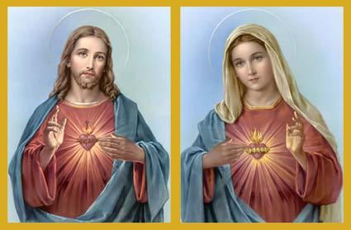
Our 44nd Annual
Walk With Jesus and Mary

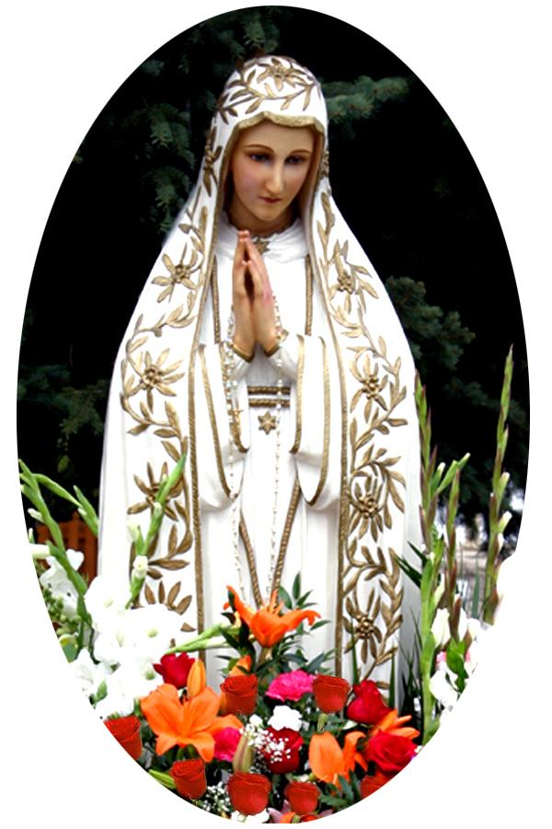 | Sponsored by Roses for Our Lady  For further information call:  Roses for Our Lady President  Kevin Ricard at (414) 571-9378  or email at rosesforourladymilwaukee@gmail.com  www.rosesforourlady.org

